Practical 4 – Data-Driven Web Based Application

Q1) Install Northwind database and create new databases.

- Install the Northwind database by typing the following command in the command prompt:
sqlcmd -S (localdb)\v11.0 -i InstNwnd.sql

- Create a new database Prac4DB1 using Visual Studio, SQL Server Object Explorer.

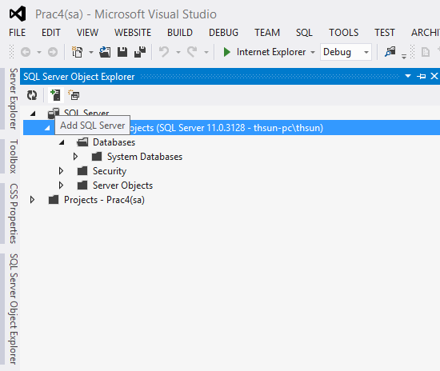

- Click on Add SQL Server

- Enter (LocalDB)\v11.0 for the Server name and Select Windows Authentication for the Authentication.
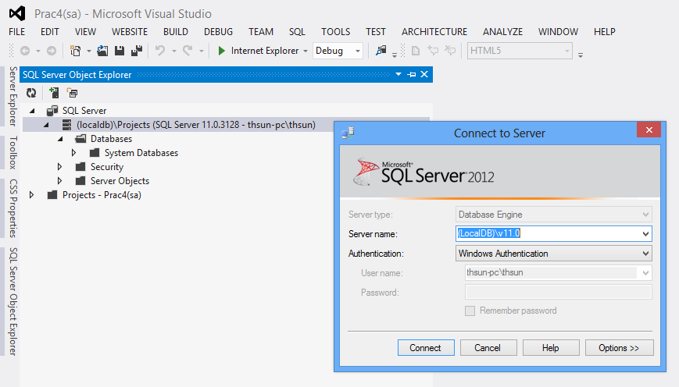
- Click Connect.
- Right click on Databases and select Add New Database
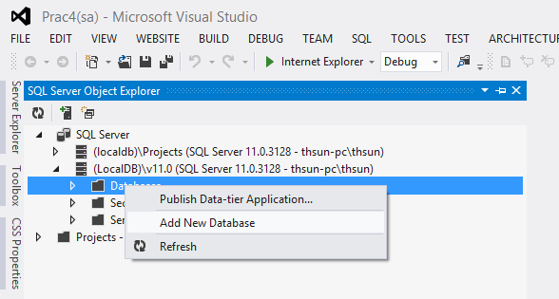

- Enter the database name and browse to the location where you want the database to be created. Click OK.

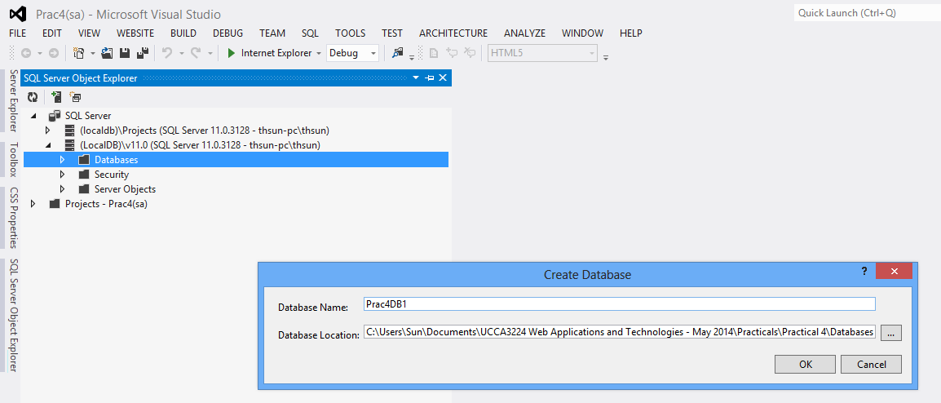

- Create a database file in the App_Data folder.

- Create the App_Data folder.

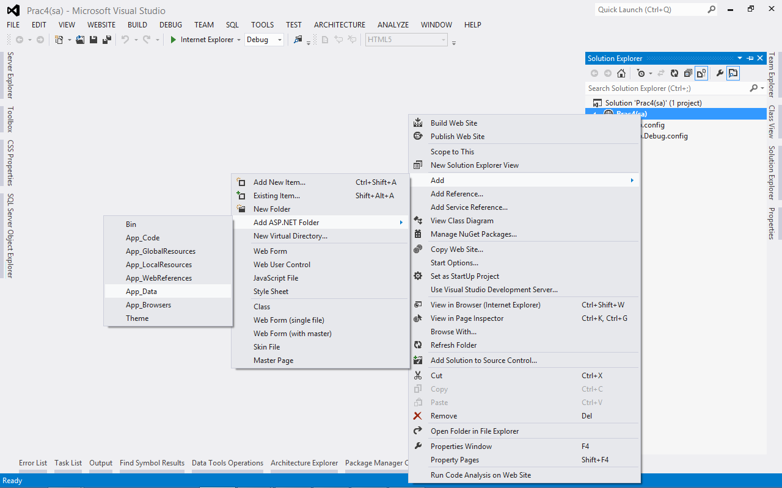

- Right-click App_Data and select Add→Add New Item.
- Select Sql Server Database and enter the name for the database. Then, click Add.

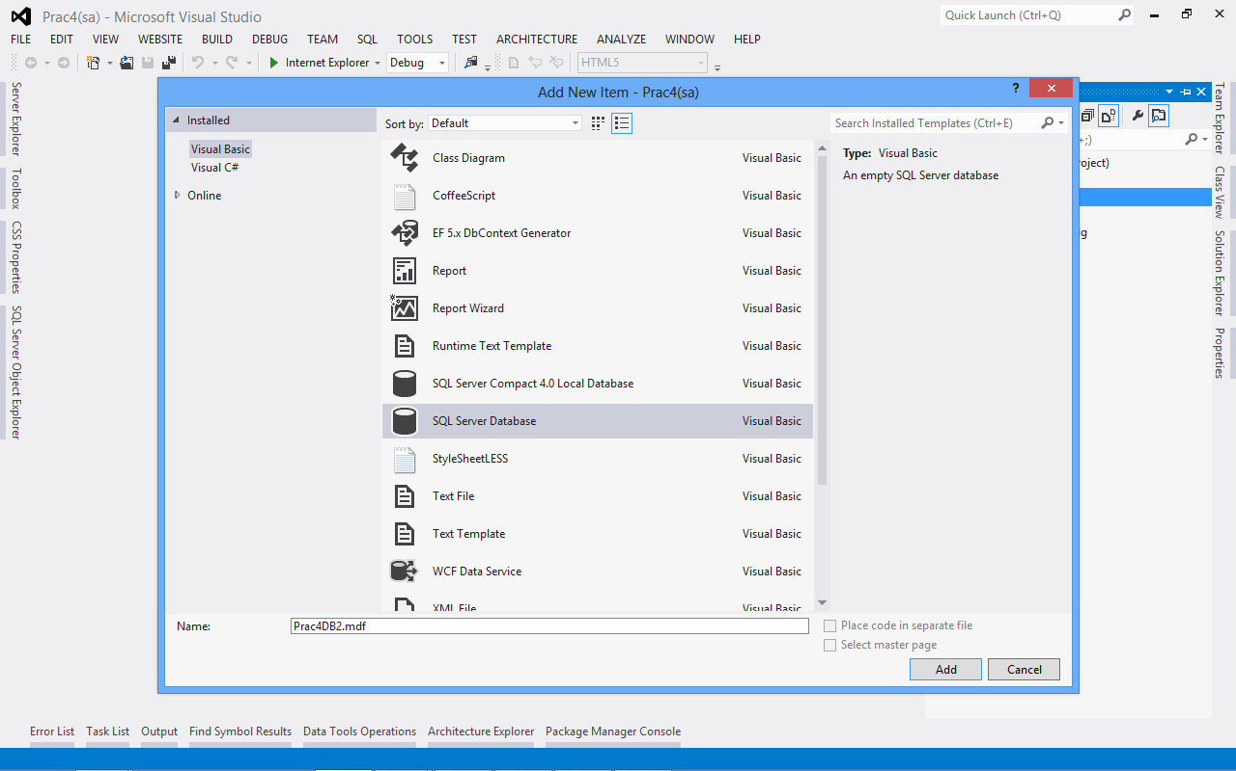

- You will be able to see the database in Server Explorer.

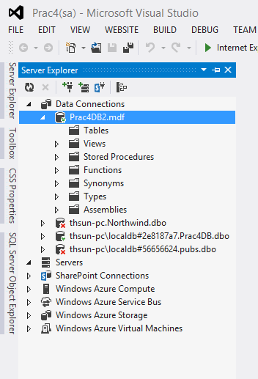

Q2) Add two tables to the database, Prac4DB2.mdf

- Double-click on Prac4DB2.mdf in the App_Data folder to expand the database in the Server Explorer.

- Right-click the Tables node and choose Add New Table, as shown in Figure 1.

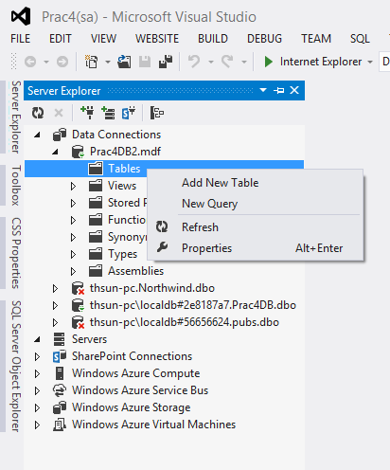
Figure 1

- In the dialog box that follows, you can enter column names and data types that together make up the table definition. Create three columns for the Id, Name, and SortOrder of the Genre table so the dialog box ends up as shown in Figure 2. Make sure you clear the check box for all three items in the Allow Nulls column. This column determines if fields are optional or required. In the case of the Genre table, all three columns will be required, so you need to clear the Allow Nulls check box.

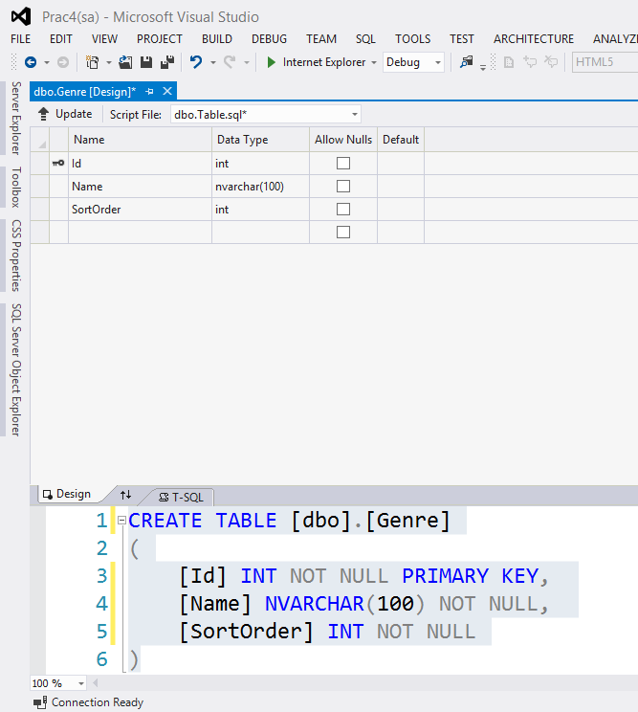
Figure 2

- You could Right-click on the column to add or remove primary key.

- Select the Id column and expand the Properties tab. Expand the Identity Specification item and then set (Is Identity) to True, as shown in Figure 3.

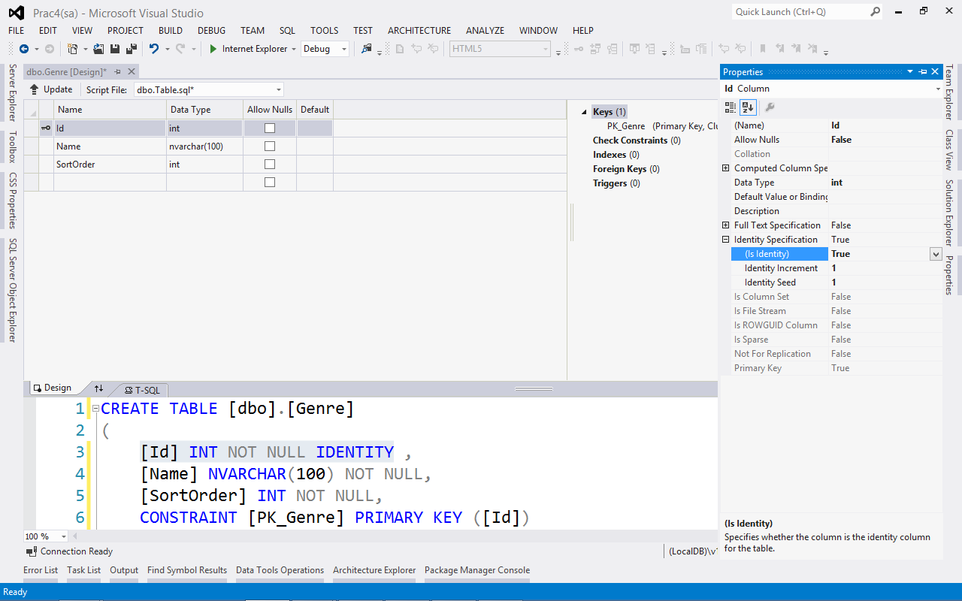
Figure 3
- Click Update.
- Click Update Database.

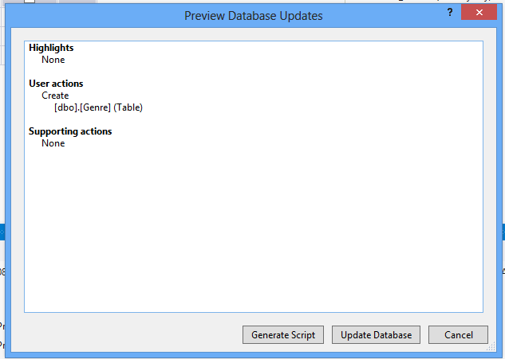

- Close the database designer.
- Create another table, but this time create a table with the following specifications to hold the CD and concert reviews.

COLUMN NAME | DATA TYPE | ALLOW NULLS | DESCRIPTION
Id | int | No | The primary key and identity of the  table.
Title | nvarchar(200) | No | Contains the title of the review.
Summary | nvarchar(max) | No | Contains a short summary or teaser  text for the review.
Body | nvarchar(max) | Yes | Contains the full body text of the  review.
GenreId | int | No | Contains the ID of a genre that the  review belongs to.
Authorized | bit | No | Determines whether the review is  authorized for publication by an  administrator. Unauthorized reviews  will not be visible on the website.
CreateDateTime | datetime | No | The date and time the review is  created.
UpdateDateTime | datetime | No | The date and time the review is last  updated.

- Make the Id column the primary key again, and set its (Is Identity) property to Yes.
- Click the CreateDateTime column once and then on the Column Properties grid, type getdate() in the field for the Default Value or Binding property, as shown in Figure 12-22. This inserts the current date and time for new rows if you don’t supply an explicit value.

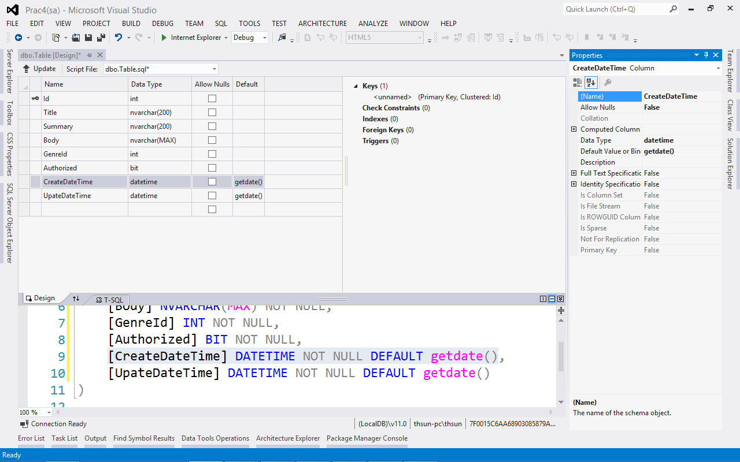

- Repeat the preceding step for the UpdateDateTime column.
- When you’re done, click Update.

Q3)
(a) Define the ConectionString for Prac4DB2.mdf in the Web.config file.

(b) Create the web form as shown in Figure 4.

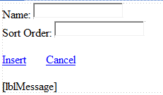
Figure 4

Use Command object to insert the record into Genre database table when Insert is clicked. Show the message “insert Successful!” or “Insert Failed!”. When Cancel is clicked, both the text boxes will be cleared.

[Note: Ensure proper error handling.]

Ans:

(a)

<configuration>
<connectionStrings>
<add name="Prac4DB2" connectionString="Data Source=(local)\SQLEXPRESS;User Instance = True;AttachDBFilename = |DataDirectory|\Prac4DB2.mdf;Integrated Security = True"/>
</connectionStrings>
</configuration>

(b)
Markup

<div>
Name:

<asp:TextBox ID="txtName" runat="server"></asp:TextBox>
<br />
Sort Order:
<asp:TextBox ID="txtSortOrder" runat="server"></asp:TextBox>
<br />
<br />
<asp:LinkButton ID="lbInsert" runat="server">Insert</asp:LinkButton>
&nbsp;&nbsp;&nbsp;&nbsp;&nbsp;&nbsp;
<asp:LinkButton ID="lbCancel" runat="server">Cancel</asp:LinkButton>
<br />
<br />
<asp:Label ID="lblMessage" runat="server"></asp:Label>
</div>

Code Behind

Protected Sub lbInsert_Click(sender As Object, e As EventArgs) Handles lbInsert.Click
' Define the ADO.NET Connection object.

Dim i As Integer

Dim connectionString As String = _
WebConfigurationManager.ConnectionStrings("Prac4DB2").ConnectionString
Dim myConnection As New SqlConnection(connectionString)
Try
' Try to open the connection.
myConnection.Open()

Dim myCommand As New SqlCommand()
myCommand.Connection = myConnection
myCommand.CommandText = "INSERT INTO [Genre] ([Name], [SortOrder]) VALUES (@Name, @SortOrder)"
myCommand.Parameters.Add(New SqlParameter("Name", Data.SqlDbType.NVarChar))
myCommand.Parameters.Add(New SqlParameter("SortOrder", Data.SqlDbType.Int))

myCommand.Parameters("Name").Value = txtName.Text
myCommand.Parameters("SortOrder").Value = txtSortOrder.Text
i = myCommand.ExecuteNonQuery()
If i <> 0 Then
lblMessage.Text = "Insert Successful!"
Else
lblMessage.Text = "Insert Failed!"
End If
Catch ex As Exception
lblMessage.Text = ex.Message.ToString
End Try
End Sub

Protected Sub lbCancel_Click(sender As Object, e As EventArgs) Handles lbCancel.Click
txtName.Text = ""
txtSortOrder.Text = ""

End Sub

Part 2: Try on your own.

Q4) Create the web form as shown in Figure 5to allow the user to delete a record from Genre table. Use Command object to delete a record from Genre database table when Delete is clicked. Show the message “Delete Successful!” or “Delete Failed!”. When Cancel is clicked, the TextBox and the Label will be cleared.

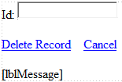
Figure 5

Q5) Create the web form as shown in Figure 6. Use Command object and DataReader to retrieve the information on the genre from the database, and display it the web form. When the web form is displayed, the record with the Id as specified in the query string will be displayed. The user can then make changes to Name and SortOrder and update the record. When Update is clicked, the Label control will either display the message “Update Succesful!” or “Update Failed”. When Cancel is clicked, the web page will be refreshed but without the query string.
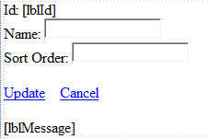
Figure 6

